Predictions Output

The **True** is the Ground truth and the **Predict** is the Predicted Value by the best Model.

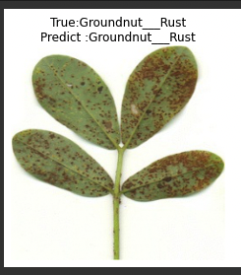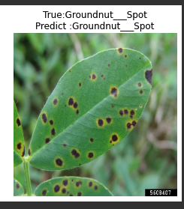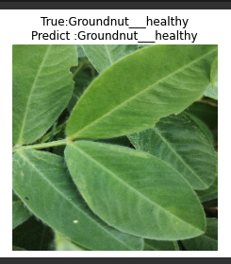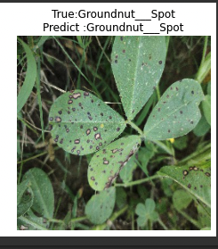

ResNet 50 : Training and Validation Accuracy / Training and Validation Loss

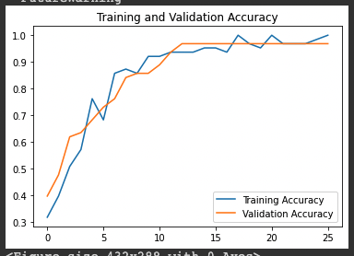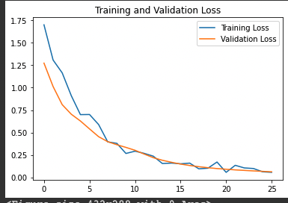

VGG Net 16 Model: Training and Validation Accuracy and Loss

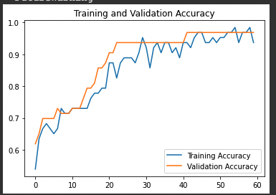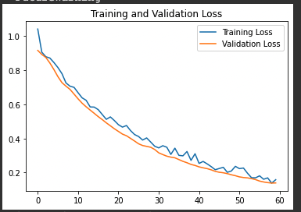

Standard CNN Model: Training and Validation Accuracy / Loss

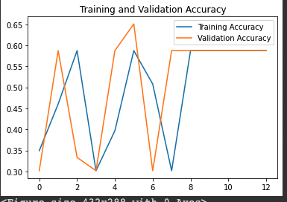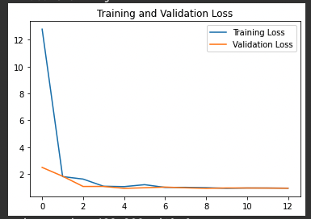

Epochs: An epoch is a term used in machine learning and indicates the number of passes of the entire training dataset the machine learning algorithm has completed. Datasets are usually grouped into batches (especially when the amount of data is very large).

**Epochs Taken to Train Each Model:**

Standard CNN : 13 Epochs – Validation Accuracy did not improve after 0.65

VGG Net 16 : 43 Epochs to get Validation Accuracy of 0.93

ResNet 50 : 27 Epochs to get Validation Accuracy of 0.96

**Input Size of Every Image: 250 x 250**

**ResNet50 has 48 Convolution Layers + 1 MaxPool Layers + 1 Average Pool Layer**

**Resnet50 Architecture: (sourced from Web)**

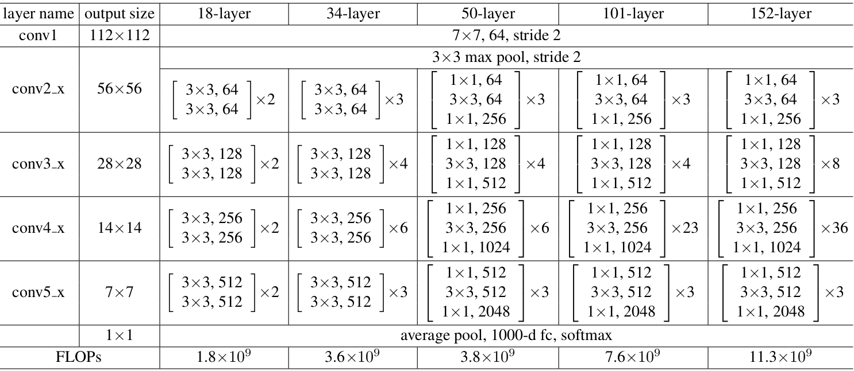

**We use Ensemble Methods to give the best accuracy rate by combining ResNet50 and Vgg16 Model. The Combined Accuracy is about 96.8 %.**

**We have tweaked our Resnet Model with some of the paprameters changed below.**

**Parameters Changed in the ResNet :**

The shortcut connections skipped two layers but now we skip three layers and also there was 1 * 1 convolution layers

1. Conv2D (64, (3,3), activation = ‘relu’) - Here we are changing the learning of total of 64 filters instead of 32
2. MaxPooling2D(pool_size=(3, 3)) – We are setting the max pool size of 3,3 than 2,2
3. Flatten() – Then we are flattening the data into 1-D array for inputting into the next layer
4. Dense(256,activation='relu') – Then Specifying the dense layers to receive inputs from all the neurons of the above customized layers customized layers.
5. Dense(3,activation='softmax')

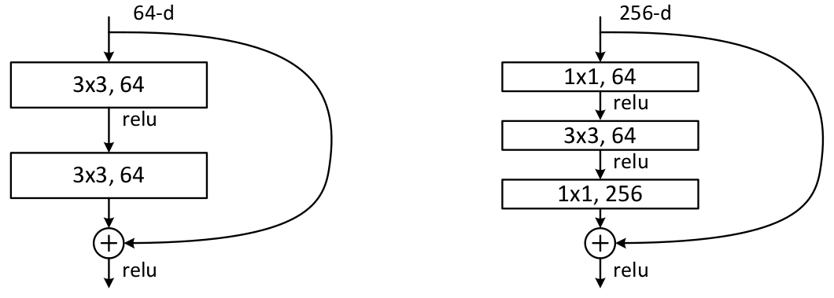

* A convolution with a kernel size of 7 * 7 and 64 different kernels all with a stride of size 2 giving us **1 layer**.
* Next we see max pooling with also a stride size of 2.
* In the next convolution there is a 1 * 1,64 kernel following this a 3 * 3,64 kernel and at last a 1 * 1,256 kernel, These three layers are repeated in total 3 time so giving us **9 layers** in this step.
* Next we see kernel of 1 * 1,128 after that a kernel of 3 * 3,128 and at last a kernel of 1 * 1,512 this step was repeated 4 time so giving us **12 layers** in this step.
* After that there is a kernel of 1 * 1,256 and two more kernels with 3 * 3,256 and 1 * 1,1024 and this is repeated 6 time giving us a total of **18 layers**.
* And then again a 1 * 1,512 kernel with two more of 3 * 3,512 and 1 * 1,2048 and this was repeated 3 times giving us a total of **9 layers**.
* After that we do a average pool and end it with a fully connected layer containing 1000 nodes and at the end a softmax function so this gives us **1 layer**.

Confusion Matrix of our best Model: ResNet50 + Vgg16

